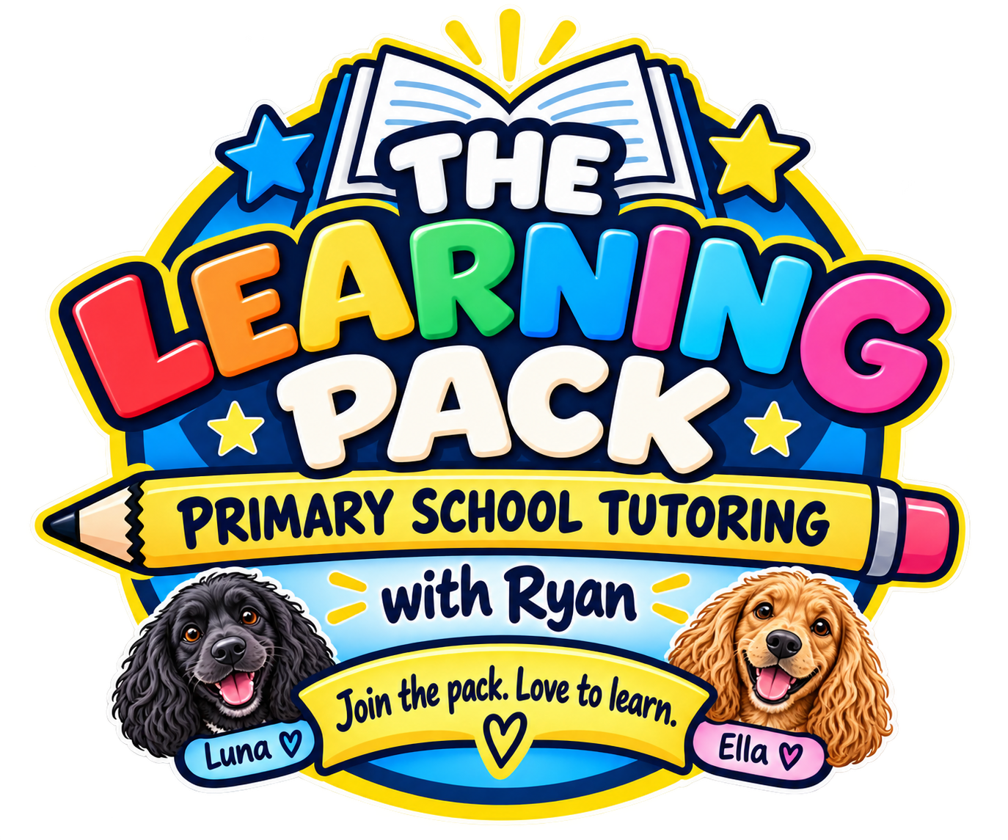 | Parent Learning Profile  THE LEARNING PACK | Primary School Tutoring with Ryan  Tell us what your child needs so each lesson can start from the right place.

Please complete this form before the first lesson. Your answers will help Ryan plan supportive, enjoyable and purposeful tuition for your child.

About your child

Child's full name  ________________________________________________________________________________ | Preferred name  ________________________________________________________________________________
Date of birth  ________________________________________________________________________________ | Year group  ________________________________________________________________________________
School  ________________________________________________________________________________ | Class teacher  ________________________________________________________________________________
Parent or carer name  ________________________________________________________________________________ | Telephone number  ________________________________________________________________________________

What support are you looking for

☐ MATHS | ☐ ENGLISH | ☐ READING

Also needed ☐ Homework help ☐ Catch up ☐ Misconceptions ☐ Confidence ☐ Challenge
Preferred lessons ☐ Weekly ☐ Fortnightly ☐ Monthly ☐ To be agreed
What would you most like your child to gain from tutoring? Please describe your main priorities and goals.
________________________________________________________________________________
________________________________________________________________________________
________________________________________________________________________________
________________________________________________________________________________

What are they finding difficult at the moment? Include specific topics, skills or examples.
________________________________________________________________________________
________________________________________________________________________________
________________________________________________________________________________
________________________________________________________________________________
________________________________________________________________________________

What has school advised or identified? Include targets, assessment information or comments from their teacher.
________________________________________________________________________________
________________________________________________________________________________
________________________________________________________________________________
________________________________________________________________________________

How do they manage homework and independent learning?
________________________________________________________________________________
________________________________________________________________________________
________________________________________________________________________________

Parent Learning Profile
THE LEARNING PACK | Primary School Tutoring with Ryan
Help Ryan understand how your child learns, what motivates them and how to support them well.

Strengths interests and motivation

What does your child enjoy or do well at? In school or outside school.
________________________________________________________________________________
________________________________________________________________________________
________________________________________________________________________________

Favourite interests, hobbies, books, characters, sports or topics These can help make lessons engaging.
________________________________________________________________________________
________________________________________________________________________________
________________________________________________________________________________

Activities, topics or approaches they dislike or prefer to avoid
________________________________________________________________________________
________________________________________________________________________________
________________________________________________________________________________

How your child learns best

They respond well to ☐ Visuals ☐ Talking ☐ Practical resources ☐ Games ☐ Short tasks
Helpful during lessons ☐ Movement breaks ☐ Quiet work ☐ Praise ☐ Rewards ☐ Extra thinking time
What advice would you give Ryan about working successfully with your child? Include what builds confidence and what can cause worry or frustration.
________________________________________________________________________________
________________________________________________________________________________
________________________________________________________________________________
________________________________________________________________________________

Any SEND, medical, allergy, sensory, communication or wellbeing information Include helpful adjustments or strategies.
________________________________________________________________________________
________________________________________________________________________________
________________________________________________________________________________
________________________________________________________________________________

Anything else Ryan should know
________________________________________________________________________________
________________________________________________________________________________
________________________________________________________________________________

Parent or carer agreement

I confirm that this information is accurate to the best of my knowledge and will share relevant changes. It may be used to plan and deliver tuition, support my child's wellbeing and administer the service.
Parent or carer signature  ________________________________________________________________________________ | Name  ________________________________________________________________________________ | Date  ________________________________________________________________________________

Thank you - together we can help your child learn, grow and achieve.

